Pish-Hussar
(Nikodem Drabik)

Plymouth University
Comp 3000 - Dissertation

Contents – Words 513
1 Vision 5
1.1 Problem Statement 5
2 Literature Analysis 5
2.1 Current Issues 5
2.1.1 Threat Analysis 5
3 Market Solutions 7
3.1 Training 7
3.2 Phishing Filters 7
3.3 Current market software 7
3.3.1 Avanan 7
3.3.2 Cofense PDR 8
3.3.3 Mimecast 8
3.3.4 Evaluation 8
3.4 Current Market Extensions 8
3.4.1 Anti Phishing 8
3.4.2 Criminal IP: AI-based Phishing Link Checker 8
3.4.3 PIXM phishing Protection 8
3.4.4 Evaluation 9
4 LESP 9
4.1 Legal 9
4.2 Ethical 9
4.3 Social 10
4.4 Professional 10
4.5 MVP Objectives – SMART 11
4.5.1 SO1 Email Parsing 11
4.5.2 SO2 URL threat analysis 11
4.5.3 SO3 Natural Language Processing 11
4.5.4 SO4 User Risk Score Interface 11
4.5.5 SO5 User Accessibility 12
4.5.6 SO6 Customisable Security and Privacy Settings 12
4.6 Requirements 12
4.6.1 Functional Requirements 12
4.6.2 Non-Functional requirements 15
5 Project Planning 16
5.1 Agile 16
5.2 User Stories 17
6 Methodology 18
6.1 Programming Languages 18
6.2 API 18
6.2.1 WHOISJSON API 18
6.2.2 VIRUSTOTAL API 18
6.2.3 Phish Husser API - URL Extender & Database 18
6.2.4 Risk Matrix 19
7 Solution Planning and Prototyping 21
7.1 Process plan v1 21
7.2 Process plan v2 22
7.3 Prototype v1 24
7.4 Prototype v2 24
7.4.1 Images 24
7.4.2 Changes 25
7.5 Prototype v3 26
7.5.1 Images 26
7.5.2 Changes 26
7.6 Prototype v4 27
7.6.1 Images 27
7.6.2 Changes 28
7.7 Phishing Link 29
7.7.1 GitHub 29
7.7.2 Extending the URL 30
Testing 30
8 Testing 31
8.1 User Bias 31
8.2 The users 31
8.3 Testing v1 31
8.3.1 Testing Outcome 32
8.3.2 Testing action taken 32
8.4 Testing v2 33
8.4.1 Objectives 33
8.4.2 Objective – Phishing Awareness 33
8.4.3 Re-testing with application 37
8.5 User testing 38
8.5.1 Open the tool 38
8.5.2 Navigate to security settings 38
8.5.3 Modify Security Settings 39
8.5.4 Review what services are available 39
8.5.5 Scan Email / run tool 39
8.5.6 Analyse the analysis information 39
8.5.7 Other Feedback 39
8.5.8 Improvements 40
9 Sprints 42
10 Final Solution 43
10.1 Architecture 43
10.1.1 Code Base 43
10.1.2 Technology 45
10.1.3 Pipeline 46
10.2 User Interface 46
10.2.1 Considerations 46
10.3 Final Performance 47
10.4 Security & Privacy 47
10.4.1 Chrome Extension Security 47
10.4.2 Secure Communication 47
10.4.3 User Choice 47
10.5 Error Handling 48
11 Deployment 48
11.1 Beta Deployment 48
11.2 Production Deployment 48
11.2.1 User Data Policy and EULA 48
11.2.2 API 48
11.2.3 Cost 49
11.2.4 API payments 49
11.2.5 Documentation / Tutorial 49
12 Evaluation 49
12.1 Requirements 49
12.1.1 Functional Requirements 49
12.1.2 Non-Functional requirements 50
12.1.3 Conclusion 50
12.2 What Went Well 50
12.3 What Need Improvements 50
13 CPD 50
13.1 PlymHack 2026 50
13.2 Devon & Cornwall Forensics 51
14 References – Words 601 51
14.1 Extensions 53
15 Apendix 53
15.1 Risk Assessment Methodology 53
16 MORE STUFF 54

Vision

Problem Statement
Phishing attacks are one of the largest threats I the cyber security landscape. National Cyber Security Centre reports that 93% of businesses and 95% of charities have been affected. This is despite of large amounts of enterprise level solutions, spam filters and tools that are often incorrectly configured, and many people fail to acquire a tool for phishing. As a result of this increasingly placed with the end user, which is an increasingly challenging skill to acquire especially for the technologically inexperienced and vulnerable groups like the elderly.
Current Consumer tools offered limited transparency providing limited explanation of reasons for flagging emails and this fails to build the users own awareness or long-term resilience. This solution aims to fill this gap by developing a chrome extension that analyses an email real time and assigns the risk score based on the URL and the language pattern. And presenting findings in plain and accessible language to all users.
The final goal is to not only alert the user of potential thereat but to educate them long term. Functioning similarly as a companion guiding the user through the internet.

Literature Analysis

Current Issues

Threat Analysis
Phishing remains one of the largest cyber threat, Reports indicate that on average 83% of organisations experience phishing attacks [1]. With an increase in cyber security training, it still human error represents 70% of entry points [4].
As a result, this indicates that the controls reduce risk however, limitations of current training programmes do not eliminate human susceptibility. The distinction between phishing attempts and successful breaches indicate that controls like filters, tools and training are partially effective but insufficient in isolation. This is because human error plays a large factor, benefiting the attackers.
As a result, an effective solution would provide:
- real-time assistance
- contextual feedback
Reducing reliance on user memory reinforcing secure behaviour and implementing human in the loop solutions.

Email attack vector
Email phishing attacks predominantly utilise user re-direction tactics. With reports indicating that 52% [5]-60% [9] of phishing email contain malicious embedded links. Additionally, attackers exploit brand trust with 32.3% [6] impersonating a brand and performing human engineering to deploy these attacks. These links often lead to external sites credential harvesting tools or malware dropping putting emphasis on post click behaviour.
This indicates that detection systems must go beyond only email analysis and perform:
- URL inspections
- redirect analysis
- destination analysis.

Targets
Analysis of the demographics indicate that individual’s aged 22-45 are more target, however those aged 75+ are disproportionally experiencing higher financial loss [7] This likely due to lower digital literacy skills within one-third of individuals 65+ [8]. However, this may be influenced by the fact the 75+ sector is 8.5% of the population compared to 22-45 being 25% meaning less data points. As well as high likelihood that the 75+ sector are less literate and as a result be less likely to detect and report fraud.
In conclusion this reinforces the need for:
- Accessible UI
- Non-technical explanation

AI enhanced attacks
Recent research highlights the increase of AI to generate “hyper personalised” phishing attacks at scale and at lower costs. A study indicates significantly higher rates of engagement with an increase of 350% click through compared to traditional techniques.[10] However this is dependent on the scenarios and target demographic.
Additionally, the costs and time required has significantly reduces enabling low skilled attackers with limited resources to deploy high quality campaigns.
As a result of this a good solution should:
- Go beyond key word analysis
- Use datapoints other than text

Attackers
With the decrease of cost and the increase accessibility of tools has led to a rise to Phishing as a Service (PaaS) with tool like WormGPT and FraudGPT enabling attackers with limited skill to launch campaigns and statistics state this is an growing threat [14].
This indicates that these attacks are:
- More Scalable
- More Accessible
- Harder to defend
- Geopolitically Motivated
- Financially Motivated
As a result of this a solution needs to be:
- Easly adaptable
- Modular
- Scalable

Market Solutions

Training
Training remains and is likely to remain a key mitigation strategy. Research on human learning indicates that spaced learning improves long-term retention [2] as well as failure to sustain leads to a drop in security [15]. However, in companies, training programs require:
- Employee time
- Financial investment
- Continuous Reinforcement
Additionally personal improvements require:
- Cost of Training
- Time
As a result of this a good solution for this problem would:
- Continuously Reinforce
- Be low cost
- Minimal user interaction time

Phishing Filters
Phishing Filters provide an automated first layer of defence. It analyses email content and blocks known malicious sources. Yet its limitations are:
- Effectiveness decreased when emails from trusted sources
- Misconfigurations reduce protection
- Black Box model
Minimal transparency to end user reduces their understanding and does not improve long-term behaviour changes.
A solution based on this should provide:
- Explainable User facing risk analysis
This will allow the user to understand the why and develop long term.

Current market software

Avanan
Cloud based email-security solution that analyses user relationship and trust levels. Additionally extends protection to Teams and Slack.
Limited to enterprise tasks, reduced accessibility to users, limited transparency on risk decisions.

Cofense PDR
Leverages AI with professional human in the loop to identify phishing attacks in real time, quarantines events and provides global threat sharing
Highly effective on organisational scale, lacks in personal use and does not educate or explain events.

Mimecast
Provides advanced phishing detection including sandboxing and link analysis
However, solution is cloud centric and limits user visibility into decision making process, reducing educational value for user.

Evaluation
Overall current market solutions are strongly targeted towards enterprise environments than individual end-users.
A strong pattern can be seen:
- Strong Detection capabilities
- Weak User education
- Limited transparency
- High deployment complexity
This indicates that while enterprise solutions are effective at preventing phishing; they fail to address the human element of susceptibility and attempting to eliminate it however only mitigating it; which is a consistently identified as a primary vulnerability in literature.

Current Market Extensions
(Links in references)

Anti Phishing
Warns when accessing blacklisted websites.
Limitation - Reactive solution, ineffective against new phishing domains. No education of user

Criminal IP: AI-based Phishing Link Checker
Checks a link is malicious using WHOIS, AI and CTI database. Provides a easy user-facing explanations. Provides good user protection techniques. Aimed at personal use.
Limitation - Fails for obfuscated links requires user to manually identify all links.

PIXM phishing Protection
Uses AI to scan webpage for Logos and verifies if page is or is not owned by the stated website.
Limitation – Requires entering website, any executable on launch of website is performed.
Good solution for secondary evaluation.

Evaluation
Overall, existing solutions provide partial solutions, each optimised for a specific approach.
Overall Issues –
- Single dimension analysis (wording or links or domain)
  - limiting protection against multi vector attacks
- Lack of user contextual feedback overall
  - User will never learn to self-diagnose attacks
A solution that fills these gaps in the market would:
- Perform multi-source analysis
- Provide Transparent Contextual feedback
- User does not access website
- Identification of all links
- Real-Time risk analysis

LESP

Legal

Phish-Hussar is designed with accordance with UK-GDPR and Data protection Act 2018. The system processes emails which may contain personal data for phishing classification; hence, GDPR principles under Article 5 are fundamental, specifically Data Minimisation (Art 5(1)(c)) and Purpose and Storage Limitation (Art 5(1)(e)).
The Processing is justified under Legitimate Interests (Art 6(1)(f)), where in this instance legitimate interests is detection and prevention of phishing attacks.
To ensure compliance with accountability requirements of Article 5(2), documentations of processing activities, dataflow diagrams and logs where appropriate. And prior to public release according to Art 35 a Data Protection Impact Assessment will be performed.
Furthermore, transparency obligations under Articles 12-14 GDPR will be done through explanations within the user interface, ensuring that user is aware of what data is processed and how.
Where third party services are used this will be clearly disclosed to the user. Additionally, all third-party services will be modular allowing the user to disable them.
Lastly design will consider alignment with ISO/IEC 27001 (information security management and ISO/IEC27701 (privacy information management), particularly in relation to secure data handling, access control and privacy-by-design principles.

Ethical
Phish-Hussar is built around user-autonomy ensuring that all outputs are advisory rather than deterministic and the user can make the final informed decision.
To ensure non-maleficence, the software will avoid fear based and coercive design. Instead ensure explanations are educational and reduce anxiety while being effective.
Transparency is a core requirement and done through explainable outputs. Rather than presenting opaque outputs the software should understand reasoning behind each assessment. This will mitigate risks on over-reliance on automated decision making. However, it will be the user’s responsibility to engage with the software as intended.
Additionally, design will consider accessibility across variety of technical abilities. The design will avoid disadvantaging users who may lack specific skills.
Lastly training data and use cases may present unexpected biases as a result disproportionate error rates across users. This can be omitted with larger scope training data.

Social
Phish-Hussar is designed for a diverse user base including elderly, young users, visual impairments, and particularly those who have lesser tech-literacy. As a result of this the interface accessibilities features should accommodate as much of the scoped user base; ensuring that text is readable to all users.
Additionally, the language is intentionally simplified to improve comprehension.
When risk is identified, the warning must be structured in an educational manner and as guidance to improve target long term literacy rather than short term compliance.

Professional
The project will follow an Agile development process for flexibility and continuous improvement. This allows me to quickly adapt to new phishing methods and release regular patches for new attack vectors.
Testing will involve real users from the target audience to ensure accessibility, readability, and ease of use. Bug testing will be frequent, with detailed crash logs to speed up fixes.
Version control will separate test builds from stable releases to keep the project organised and prevent data loss.
All testing and analytical data will be clearly disclosed, with users knowing exactly what information is being collected and why.
The EULA and TOS will be written in simple, direct language so users can understand their rights, privacy protections, and data usage without needing legal expertise.

The project will follow AGILE methodology by having iterative spring cycles, backlog and continuous evaluation. This ensures adaptation to emerging technologies and evolving threat landscape.
Software engineering practices align with SOLID principles ensuring the software will be maintainable, modular and testable. Thought the project unit testing, integration testing will be performed for all modules. With User Acceptance Testing to conclude the MVP development.
Security and reliability through logging, error handling and version control of software to ensure final solution aligns with secure software development lifecycle.
Thought the project continuous review of objectives and project alignment with any deviations documented and justified.

MVP Objectives – SMART
SOx is abbreviation of Smart Objective x

SO1 Email Parsing
Specific – Extract Gmail body from DOM via extension
Measurable – Correct extraction and segmentation of >90% on 20 test emails
Achievable –
Relevant – All downstream modules depend on this data
Specific – Operational and parsing >95% by end of sprint 4

SO2 URL threat analysis
Specific – decompose URL, compare to acquired data query external data sources return risk score, extend the URL
Measurable – Identified correct destination >90% of URLS and risk score classification is correct >80% based on user testing.
Achievable – REGEX decomposition, free tier of API’s, all performed within chrome extension
Relevant – URL manipulation the primary phishing vector
Time -Implement URL scanning before sprint 5 achieved score in testing prior to 5th of may

SO3 Natural Language Processing
Specific – Phishing Language detection producing a weighted language risk score
Measurable – >80% correct labelling for non-spoofed phishing emails. >20% improvement on user classification vs no tool.
Achievable – JavaScript Regex + python NLP created db.
Relevant – Addresses phishing emails that use social engineering
Time – Working MVP by ¾ of project timeline

SO4 User Risk Score Interface
Specific – Display Risk scores of SO2 & SO3, Indicate and Explain in a plain English reason
Measurable – 10% > error interpreting by user in user testing
Achievable – Final SUM with relevant pre-written explanations mapped to flags and ranges
Relevant – Bring technical analysis to be understandable by non-technical crowds
Time – Continuously improve until 5th of May

SO5 User Accessibility
Specific – All core-features accessible with two clicks. All risk indicators use color + icon or label (no-colour only) full set up in 15m (operational in 3)
Measurable – >90% of test user complete without assistance first time. Colour Scheme confirmed with colour blindness simulation tool
Achievable – Basic UI structure with a 2click limit.
Relevant – Target users will not adopt a complex and inaccessible solution
Time – Core completed sprint 4 Continuous improvement and user testing until 5th of May

SO6 Customisable Security and Privacy Settings
Specific – Every tool/module can be individually toggled with immediate effect and preferences persist in Chrome Storage. All external data sanitised before use.
Measurable – Users can toggle 100% of tools. Settings persist. Less accurate score if API’s offline
Achievable – Safe Fails around all tools. Togglable functions via settings
Relevant – Users should trust pre-set data privacy concerns,
Time – By ¾ of the project duration an MVP should be developed.

Requirements
For the MVP to be valid the solution must complete all the requirements bellow

Functional Requirements
All Human in the loop activities success rate account for human error [12]
ID | Description | Category | Acceptance Criteria | Success Rate (If applicable)

Email Parsing
FR1 | Accept Gmail email body | Extension | Extract email body from GMAIL DOM | >95%
FR2 | Analyse/process email body and dissect for variety of uses. | Analysis | All components are correctly identified and segmented. Parsed for later modules | >95%

Threat Detection
FR3 | Query minimum of one external source to improve the accuracy of risk assesment | API/DB | Results of Queries for urls are incorporated into risk score. | >95%
FR4 | Generate a numerical risk score from fr3 fr5 and fr 15. | Analysis | Generate a risk score for a dataset of a minimum of 20 ladled emails with an inaccuracy of <10% | FP/FN <10%
FR5 | Analyse email body text for phishing indicators using pattern mathching and risk assesmnets | NLP | Each indicator is assigned a weighted score. Correct labelling on non-spoofed phishing email. | >80%

User Control
FR6 | Users have sole control on tools used. Be provided the ability to enable and disable every tool/option resulting the possibility of running software with no tool resulting in no events taking place.  These changes must take place immediately after making them and before the following initiation of the tools | UI | Each module/tool can be toggled. Disabling a module stops it from performing its task. | 100%
Fr 7 | All changes are to be stored immediately on the system and persist for each session and opening of the extension | Extension | The user choice is to be saved locally and accessible after each re-load | 100%

User Interface
FR 8 | Present results the target user can comprehend in a jargon free and non-technical language. A plain text summary in the ENGLISH language. | UI | Moderated non-technical user testing scenario users can correctly identify the risk and the reason for it. With less than 20% misinterpretations | >20%
Fr9 | The Extension User Interface must be operable by first time user with no training other than reading tutorial document. All interactions after opening must happen within two clicks to minimise miss interpretation | UI | Users can complete the usability testing without external assistance. | >90%
Fr10 | User accessibility features to accommodates people with visual impairments and colour blindness. Allowing user to modify output to their disability | UI | All outputs must not simply rely on colour coding. UI must all our for customisability alongside colour blind settings. Tested against 1 colour blind simulation tool | n/a

Reliability and Handling Errors
FR 11 | Final solution must be deployable as a chrome browser extension. Installation must be achieved by a non-technical user provided with a tutorial document | Extension | The user can set up and operate the tool in 15 minutes including accessing all API keys. With a minimum passing grade of 3m to use only 1st party software (Hussar proprietary API and Software) | 15 minutes (Full Setup)  3 minutes (Minimum Setup)
FR10 | Provide Feedback on when API’s fail or unable to connect | API | Simulated API failures the user is shown a visual representation on what services are available and the software still operates using remaining services | n/a

API
FR11 | Expand Shortened URLs to the final destination prior to the analysis. | URL | All shortened URLS are expanded, and each obfuscation is added to the risk score. Identification of accurate final destination is >80% | >80%
FR12 | Use of WHO IS API data on extended URLs to identify domain age and domain legitimacy | URL | Be able to parse data from database and identify risk score | n/a

URL
FR 13 | Identify URL in email body and compare it to HREF to identify if user is being misled. | Analysis | HREF is compared to URL displayed if applicable (e.g photograph has embedded hyperlink)) | n/a
FR 14 | Split the URL to:  Protocol  Domain  .com etc / country of registry  Paths  Then identify the relevant risk score and update the risk for that specific section. | Analysis | Regex that can perform and handle a variety of language and styled. Additionally, it’s able to handle any erroneous inputs. | 95%
FR 15 | Risk score. URL risk score considers all relevant contributing factors from FR 14, FR 13 and FR 3 and output a risk score. | Analysis | A final risk score based on user feedback directs average user identification into the correct direction (Phishing or non-phishing) | >20% improved accuracy/ confidence

Non-Functional requirements
ID | Description | Category | Acceptance Criteria | Success Rate (If applicable)
Performance
NFR1 | Results must be calculated within 5s (not accounting for api delays) | API | Using a mid-range to low range machine and testing the time on a set of 20 emails. Must meet the threshold on more that 80% | >80%
NFR2 | No long-term storage of user data (processing only) | Privacy | No long-term data storage limited time for processing only.  User may opt in to help build algorithm and store data. | n/a
NFR 3 | Locally store any data related to user on the user’s machine. Ensuring it cannot be extracted however possibly transferable via account. | Privacy | Any data related to user preference and user to be stored on the user’s device using chrome storage | n/a
NFR 4 | Treat all data from external sources as untrustworthy. This includes all API databases email contents. All data to be sanitised before processing. | Security | Use a variety of rule sets and test using crafted emails. | %100
NFR 4 | Maintain functionality without external databases | Operation | Ensure software partially operational without any external databases.

Project Planning

Agile
I will be implementing an AGILE workflow following engineering principles including DRY, YAGNOI and SOLID to ensure maintainability scalability and clarity thought the project.
Each spring will be concluded with testing of new implementation ensure that they work within the environment additionally review to ensure they align with the goals before progressing. If objective cannot be met within time frame perform risk-based decision process. If incompleteness introduces dependency issues, reschedule the following sprints.

This approach ensures the project evolves in a controlled and verifiable manner
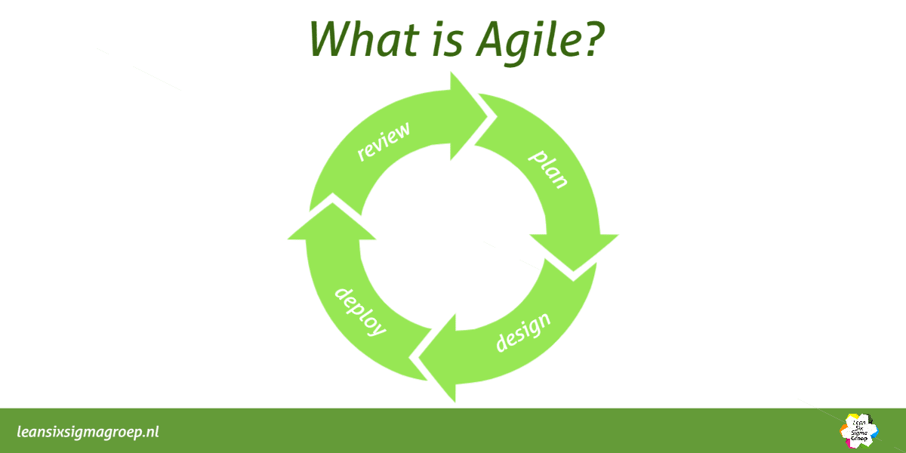

User Stories
User Need | User story | Tasks required to complete
Dangerous Links | As a user I want to be able to be able to see if a link is dangerous in an email | - Scan Email for Links  - Assess risk of link  - Give user the feedback of the links risk
Risk analysis | As a user I want to clearly know each risk score individually so I can learn the patterns | - Display the risk of the individual risks
Link Destination | As a user I always want to know where a link is heading to. | - Identify where a link destination is.
User Trust | As a user how can I be sure the risk is valid | - Use reputable databases.  - Perform rigorous testing using live phishing scams.
User control | As a user I want to have full control of what data is used and where its being sent | - Give user control on what actions are performed.
User control | As a user I want to be able to have a unique API’s so I have full control of the API used | - Allow users to provide their own API key for the services they can use.
Interface | I want a simple interface that after being set up I don’t have to do anything | - Create a minimalistic Interface that after setup user no longer must interact with it.
Visual interaction | I want the information to be displayed clearly so I can understand what is happening intuitively | - Design a interactive solution that is usable by all users no matter their disability.

Methodology

Programming Languages
- JavaScript- Core logic for all modules
- JSON – Lightweight data interchange through stack
- Python – Backend Processing and API integration
- HTML/CSS – User interface
This stack was chosen due to the comparability with browsers, ease of deployment and support for API architecture.

API

WHOISJSON API
Used to get information about the site such as
- Domain Age
- Certificate
- Last Modification Date
Phishing websites often have short life spans [13] and inconsistent configurations. These attributes act as heuristic indicators rather than definitive proof.

VIRUSTOTAL API
Database providing risk intelligence for multiple security vendors.
This allows cross-validation of locally generated risk scores improving accuracy and using large-scale threat intelligence.
However, it delays on reporting zero days threats and rate limit on API.

Phish Husser API - URL Extender & Database
API implemented to:
- Extend shortened URLS and redirects
- Interface with SQL database for NLP key word risk assessment.
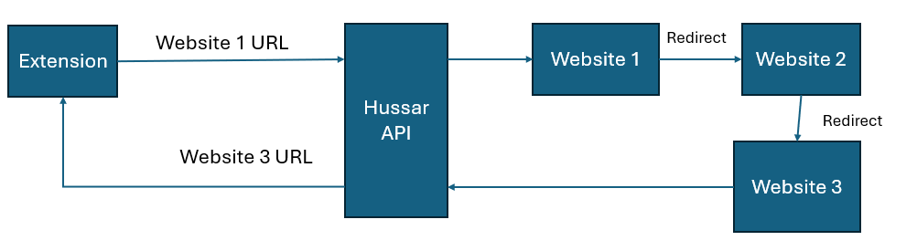
[Diagram of Hussar API extending URL]
DRY&SOLID consideration is that the functionality is in a single service to avoid duplication and ensure consistency across deployments.

Risk Matrix
Risk analysis will be conducted using likelihood * impact(consequence) model by looking at guidance from ISO 27005 section 7.3[9], where risk is the probability of the event multiplied by impact on the organisation.

Risk Colours
Colour | Action Required | Priority
1-5 | Lowest Priority - Accept | 5
6-9 | Monitor the event | 4
10-14 | Low Level Treatment of event | 3
15-19 | Treatment Of the event | 2
20-25 | Immediate Action Required | 1

Risk Matrix
Likelihood →  Impact ↓ | Rare -1 | Unlikely - 2 | Possible - 3 | Likely - 4 | Almost Certain - 5
Negligible -1 | 1 | 2 | 3 | 4 | 5
Low - 2 | 2 | 4 | 6 | 8 | 10
Medium – 3 | 3 | 6 | 9 | 12 | 15
High - 4 | 4 | 8 | 12 | 16 | 20
Critical – 5 | 5 | 10 | 15 | 20 | 25

Risk Assessment
Risk | Risk | Mitigation/Response | Risk Post Mitigation
Evolving Phishing Tactics | 16 | Develop Software that can be easily maintained and updated to adapt to changes. | 6
Data Privacy Concerns | 20 | Have all data processed locally where it is possible. If cloud services used or off device processing, use encrypted transmission and have a clear privacy policy and allow user to decide if to use. | 5
Challenges with integration | 12 | Start of with a small of integrated software and slowly expand the covered software. | 5
Resource Constraints | 9 | Create a project schedule and keep to it. Prioritise core functions of the software. Seek feedback on development progress. | 6
Legal Compliance and TOS | 8 | Review GDPR and relevant regulations. Have a EULA and privacy agreement before using software. | 6
Dependent API fail | 8 | If a free and opensource API fails or stops working. Paid alternatives may be used incurring additional costs of the project and may result in an unaccounted cost for users. Alternatively disable that API may reduce the effectiveness of data. | 5
Misinterpretation of warnings | 12 | Use clear and non-technical vocabulary to explain warning. Possibly add More-info tab. | 2
API limits | 15 | API calls may be limited due to not using enterprise level of software. This limits the total amount of calls I can perform daily. No Mitigation other than increasing plan at a higher cost | 10
False Positives | 10 | False positives may bring negative trust from the user for the app. However, only better algorithms can mitigate this issue. | 7
GDPR infractions | 5 | Ensure all data regarding users is explicitly explained in EULA minimise data used and stored. | 5
URL bypass attempts | 16 | Ensure the application can extend URLs to be able to find destination location to be assed | 6
MitM attack (Data source poisoning) | 10 | A source may provide false information to mask real intention of webpage. Ensure we have multiple independent data sources and review data sources often. | 6
API delays | 8 | API may provide data delayed. If delays result in unusable application identify new data sources. | 6
User Trust | 12 | Users may stop learning if they trust software or stop reading the warnings. Ensure we provide the data so it can’t be missed. If user ignores app can’t do anything else. | 6
3rd party changes their algorithm/data | 12 | Data stream may be modified leading to increase of false positives. This requires us to review our algorithm and update. | 8
UI Accessibility | 6 | Ensure the UI considers people with different disabilities and colour issues use high contrast colours that have low % of chance. | 2
File Bloat | 4 | Review Codebase every month and remove any legacy code that is no longer used to reduce file size and improve any existing code to improve efficiency. Removes any code that may create a vulnerability. | 4
Integration with browsers | 4 | Testing before use on browsers. Ensure that all functions are operating and no errors occurred when performing tests on the browser. | 4
Grayware | 6 | The software will be a MVP and in testing. Malware, Cyber Security tools and chrome may flag it as insecure. Ensure we validate the software before deployment and perform any requirements to validate apps security for these tools. | 6
Scalability Bottleneck | 12 | Using my own hardware to deploy API in the future is not viable. Use a third-party service to host like Cloudflare. (Will require cost) | 12
App Funding | 15 | If the software is to be deployed certain features will be paid for due to the costs of hosting. Ensure the user is aware of this and prepare software for this. | 9
API security | 15 | Hussar API will be receiving words and data from user emails. Ensure the data is transmitted via secure protocol and no data is stored long term. Have most if not all data processed in RAM and not stored. | 10

Solution Planning and Prototyping

Process plan v1
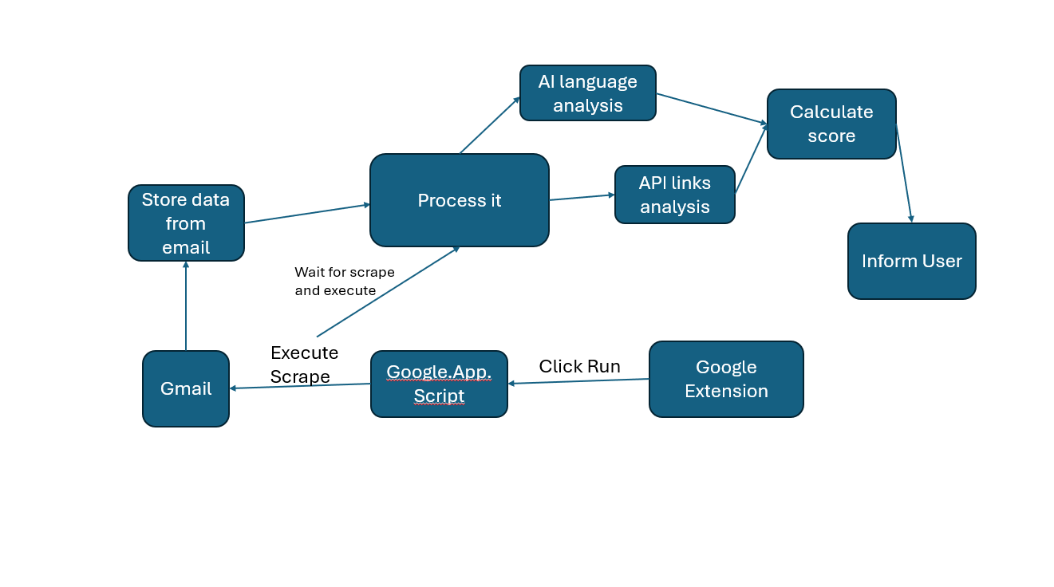
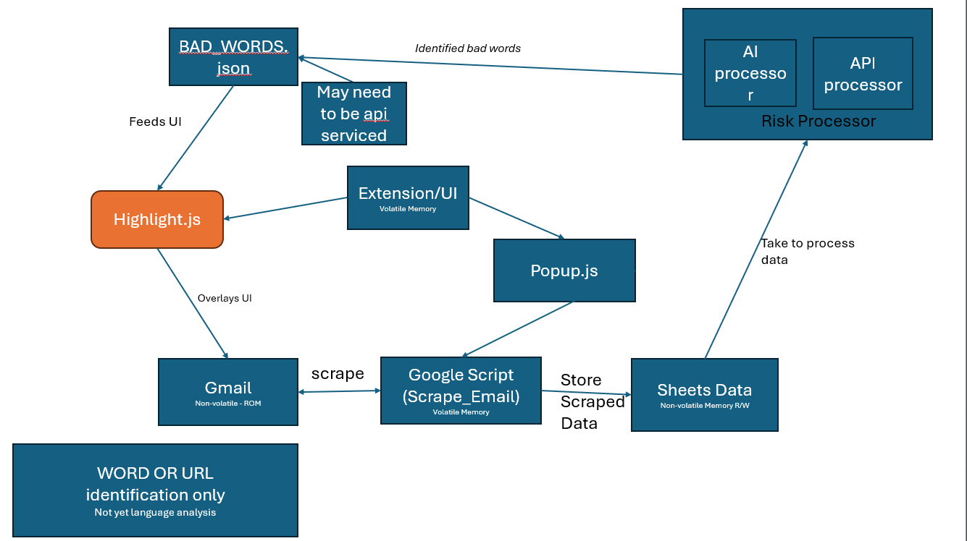
Initial estimation of how the data will be moved to perform analysis.

Process plan v2
For Words and URLS how to process the data for the user to be able to view
Chart 1:
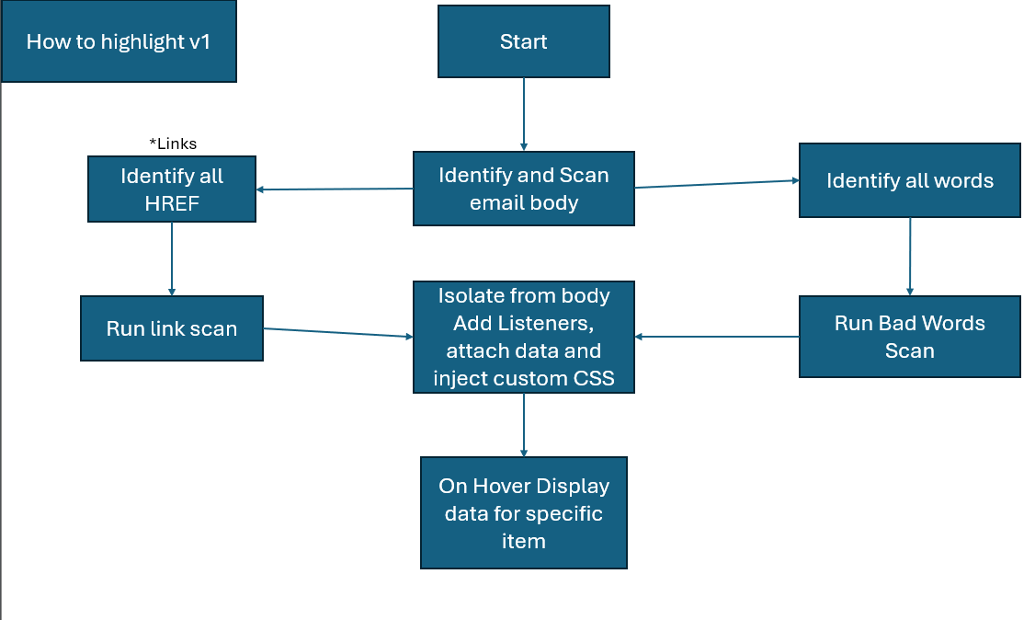

How I plan on process and reviewing the URLS to then be fed into the website this is in the “Run Link Scan” in the above (Chart 1) flow chart
Chart 2:
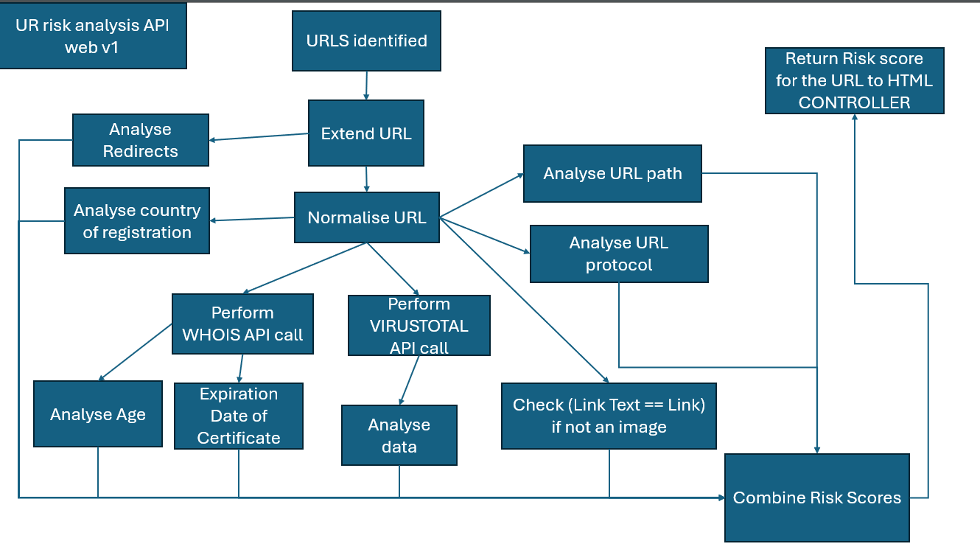
My idea of how the Highlight words would work
Chart 3:
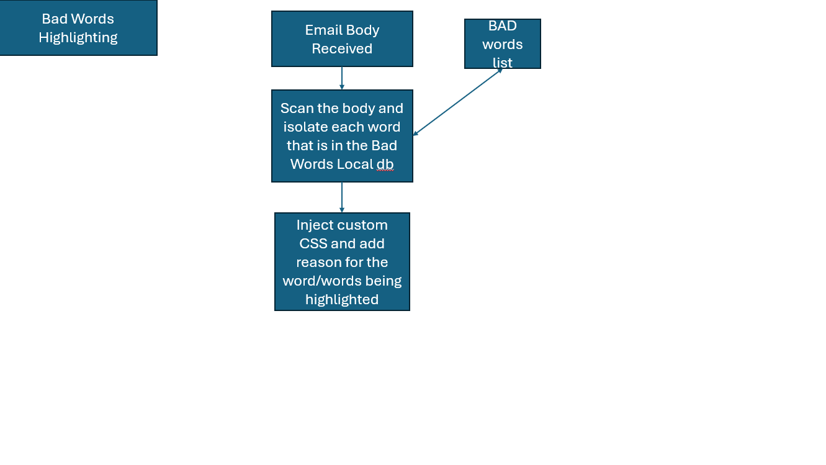

Prototype v1

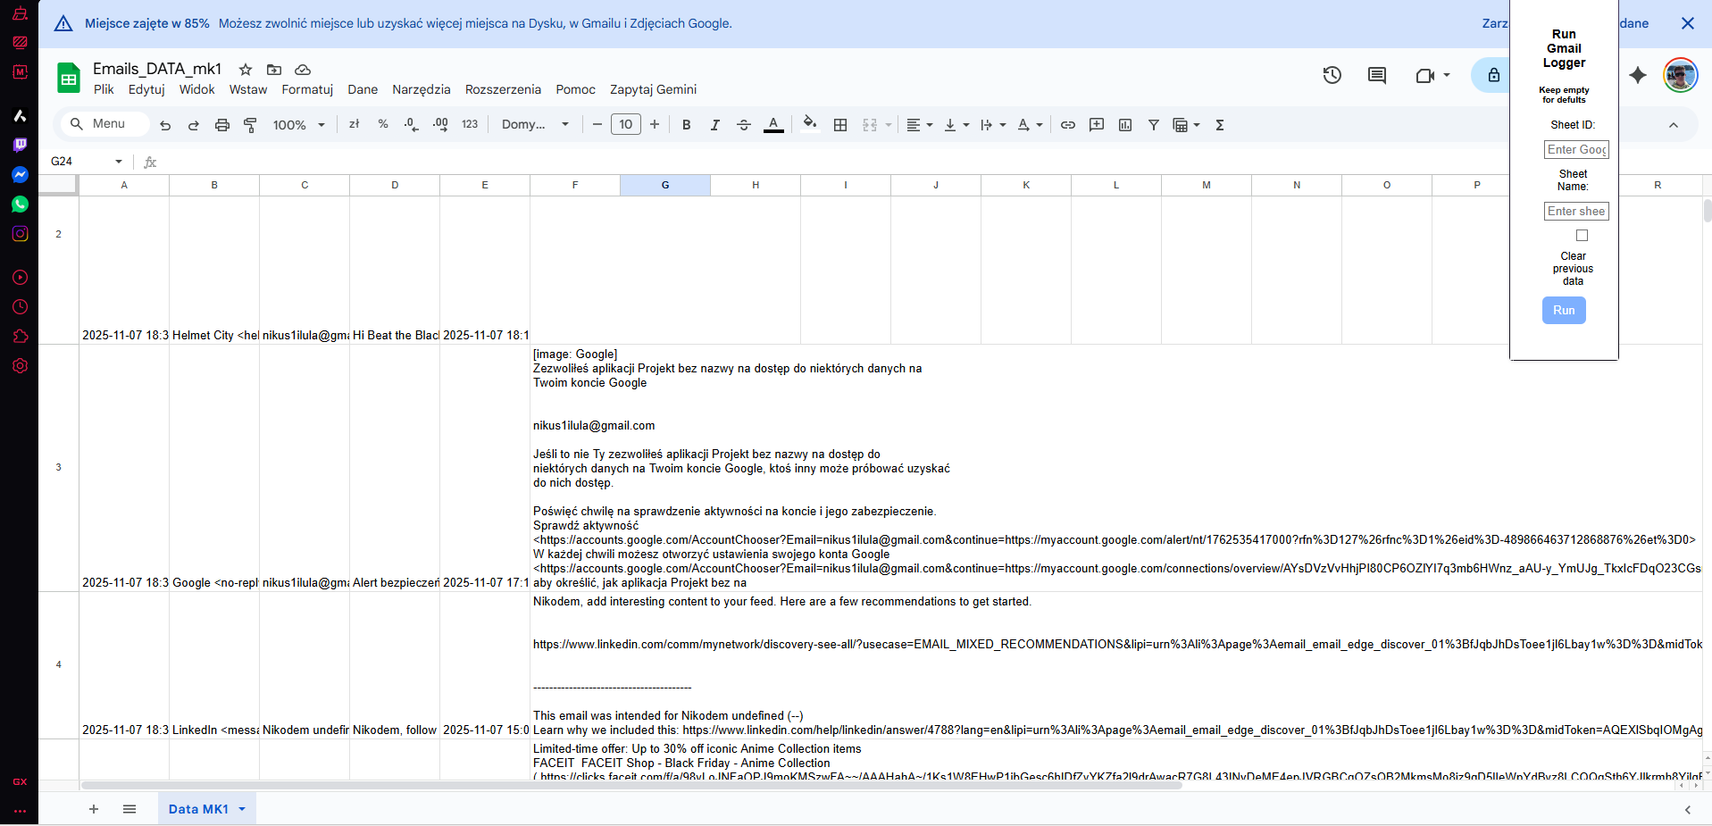
Initial prototype used the built in google ecosystem to exfiltrate the data from Gmail and store in google sheets while processing using google scripts. Using this as final solution would limit to the google ecosystem.

Prototype v2

Images
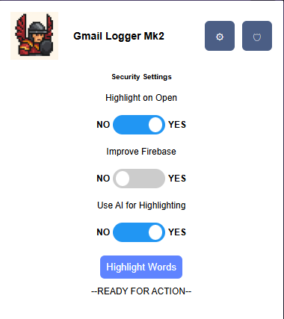
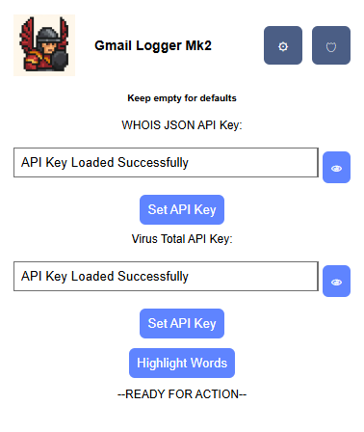
<- Settings For Api
Security Settings ->

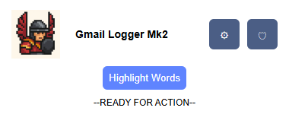

<- Extension base no expansions.

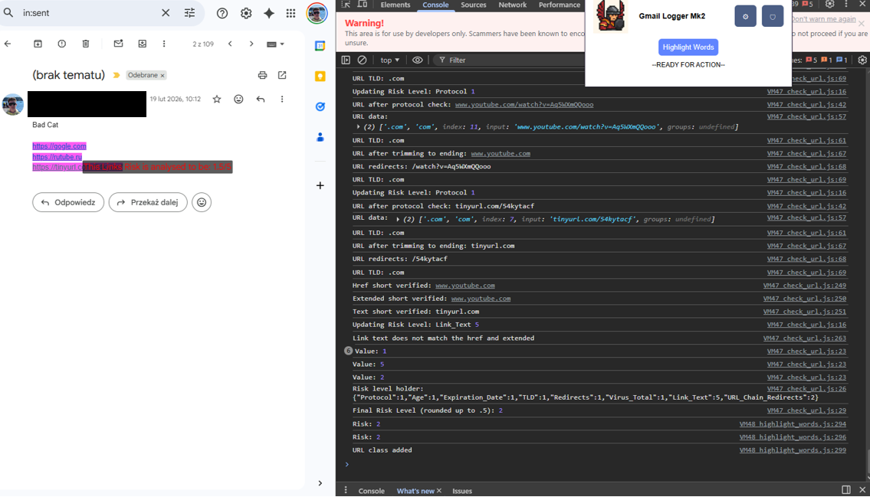
Words Highlighted in Gmail.

Changes
Created an extension. Composes of non-ecosystem languages and tools on the backend. Improved the user setup experience. No data retention takes place improving security.
Prototype 2 now has settings section and highlighting is more contrasted. Has a rudimentary setting for security which will hold all the security controls.
API settings use chrome cookies to store the API for the user and can be viewed using the view button.

Prototype v3

Images
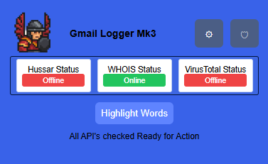 <- Main menu
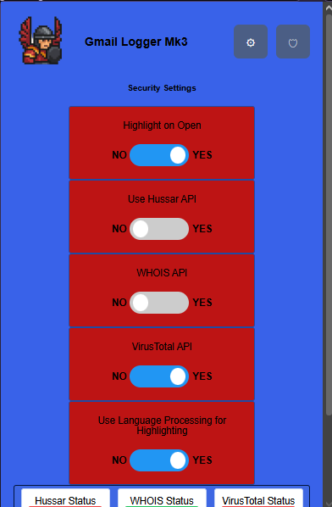
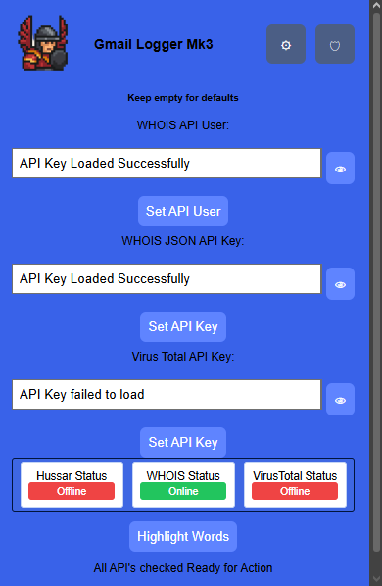
<- API Settings
Security Settings ->

Changes
In this version the following changes were made from user feedback and quality of life improvements.

API Status
The API now gets a health ping on launch of app to identify if it is alive or not to let the user know what technology will be available to use

Security Settings
Re-designed to allow the user to toggle tool improving user controls.

User Feedback
User receives updates on system stage changes.

UI
Using language over colour coding to reflect visual impairment issues. Colour re-designed to stand out for colour impaired individuals.

Sanitisation
Improved input sanitisation to prevent remote code execution.
Using a variety of regex sanitisation methods removing irrelevant special characters.

Prototype v4

Images
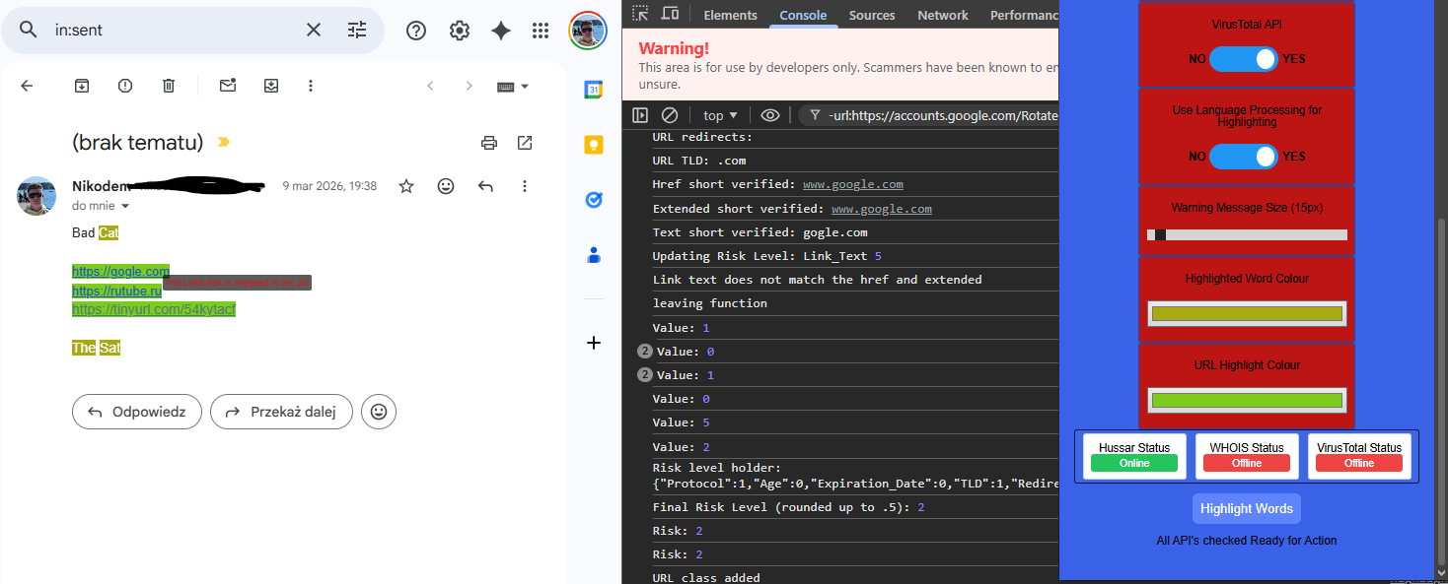
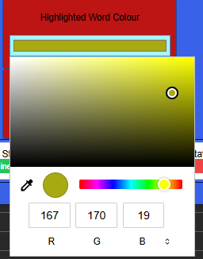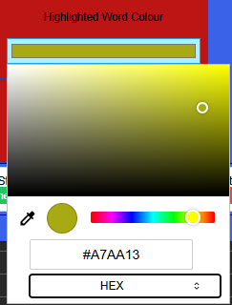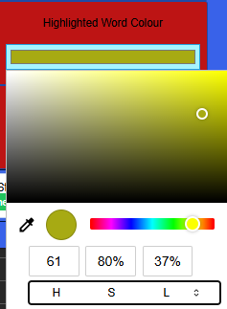

Changes

UI
Users now can change the size of the warning text and the colour of the warning text. This can be anything they would like for it to be.

Issues
Users may change the colour to something that makes the text not readable. They can change it to something that works.

Phishing Link

GitHub
https://github.com/rf-peixoto/phishing_pot/tree/main/email
This GitHub repository contains real phishing emails that have been collected via a honeypot email address and users submitted emails. Contains real malware and links to scam websites which allow the testing against real world scenarios.

Analysis of dataset
Initial testing and manual review identified the obfuscation of links that evade initial flags this requires a solution to ensure that the final identification mirrors actual risk.

Safe Websites
Sample 408 from honey pot GitHub used LinkedIn as a median to transfer the victim.
https://www.linkedin.com/slink?code=gzq-mDRH?mwmw119300
Hence this identified for me a tactic that is being used. By re-directing to a “safe” website they mask the destination. This indicates I need to find a solution to identify final location. As a result, I created an extend URL API.
Redirects to legit website to then re-direct again
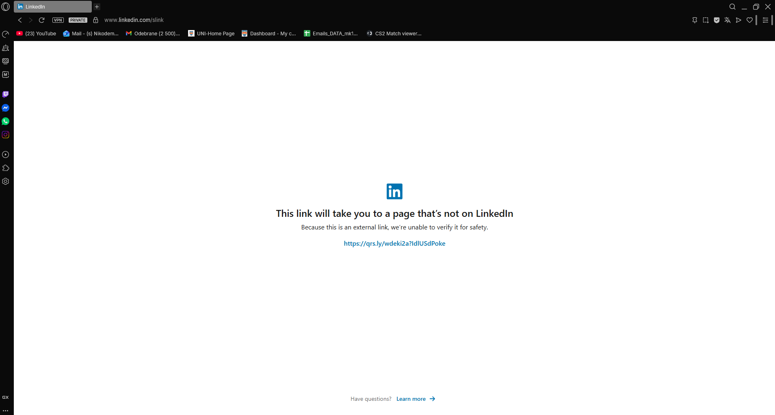
- Where it re-directed
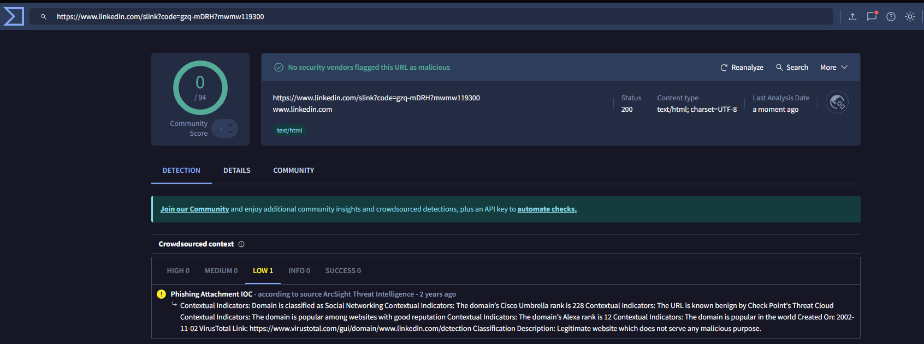
-Virus Total analysis of linked in.
This requires user input to be performed hence this attack exploits a human in the loop exploit and requires additional intrusion to prevent this exploitation. However, with the limitations imposed of no active surveillance this cannot be achieved within my scope.

Shorten URLS / Redirects
However, a second obfuscation method has a continuous path without human input. This is Soley a software attack as a result this can be solved using by finding the final destination.

Extending the URL
For this there is already an API that has been created however it could be optimised.
https://github.com/Deadpool2000/Short-URL-Expander-API/blob/main/app.py
Objective is to identify destination without executing malicious code.
- Get request for only the header of the destination website.
  - No malicious code can be executed
- Identify Location variable in the header that stores re-direct instructions.
- If present, identify next destination.
- Create a loop until no Location header exists indicating destination reached.
With this data, perform the analysis.
Testing
Original : https://www.youtube.com/watch?v=Aq5WXmQQooo
Shorten 1 (1 redirect) : https://tinyurl.com/54kytacf
Shorten 2 (2 redirects): https://urlzs.com/4OjxlY
Outcomes are that we always stop on the original URL.

Testing

User Bias
I will likely be using the same 3 users from the majority of my non-technical user tests (users with low technical knowledge). This may result in biased results due to them gaining more knowledge about the process as it goes on and near the end of the project they may be no longer “non-technical”. As a result, I will need to take this into consideration during testing and may extend my user testing.
I have access to multiple technical users from the university, and I will use them to test the features to look for vulnerabilities and errors a non-technical user may not identify.

The users
User ID | Username | Unique Identity
User 1 | Aldona | Has limited knowledge of user interface.  Uses emails frequently at work.  Limited knowledge on Phishing scams and identifying factors
User 2 | Nicole | Some knowledge on phishing scams and technical ability.  Does not use emails for communication however uses for online stores and codes
User 3 | Marcin | Rarely uses emails other than for private official purposes and online shopping.  Limited knowledge on attacks
User 4 | Joe | Cyber Security Student.  Very Knowledgeable on the attacks and spotting attacks.
User 5 | Mark | Cyber Security Student.  Very Knowledgeable on the attacks and spotting attacks

Testing v1
I had my users my first working section of my initial prototype. I had the users test the UI for interacting with the software and tell me if the highlighting was identifiable. This test was done after my own initial agile based test and have flushed out many issues.

Function | User 1 Feedback | User 2 Feedback | User 3 Feedback
Highlighted Words.  Criteria’s:  Visible  Understand the Use | Yes, its visible  After you explained, I will be able to spot it. | Visible  No issue | Maybe issue with darker/ red background  No issue
Press Highlight  Criteria’s:  Identify the button  Press the button | I can find the button without an issue.  No issue pressing the button. I like that it changes colour. | No issue  No issue | No issue
Additional comments not related to tests | I cover a lot of my screen | I like the logo.  maybe it’s too big? | Too much boxes that I don’t need. Blocks my vision of my email.

Testing Outcome
After this test of only my highlight function, I received feedback regarding my UI and with this, I will make the following changes and additional tests.
UI:
Make the UI see-through and smaller – after testing I cannot make it transparent
Make a dedicated Settings page for additional modifiers.
Hint Box may be required to explain usability

Highlight Words:
Test with different backgrounds of text as red colour may affect it.

Testing action taken
After Looking at the comments, I went and noticed that it would be useful to also add a secondary section for Security Safety now, so the UI is ready for the future.
After the testing outcomes I went back to the design elements of my UI. My initial design had flaws and here are the steps I took to develop a better UI and improve the UX. I attempted to make the Extension see through I used google documentation and stack overflow however this is not possible in google as the extension is classed as its own app and has a forced white background. So, the final changes were:

UI:
I made the UI smaller and relocated the additional settings to the to a separate tab that is a small cog.
I redesigned the sizing of sections so that the UI is more compact. The aim is that it will take up much less space than before
I made the red less of a dark red due to it making it difficult to see for the user. This may indicate that it was not visible to users with colour identification impairment specifically Protanopia (red colour deficient).

Testing v2
Testing using a variety of users to use the whole process of the application
https://forms.gle/x7LgtYJHvbQ2eXT17

Objectives
- Understand a baseline of user phishing awareness
- Get user to test extension
- Test if tool improves user detection of phishing
- Feedback

Objective – Phishing Awareness
For this section I provided the user with a combination of phishing and non-phishing emails to understand their perception. Users would be provided with an email and had to rate it 1-10 with 1 being legitimate and 10 scam where 5 was unsure. For this section I had 6 users.

The emails

Scam email
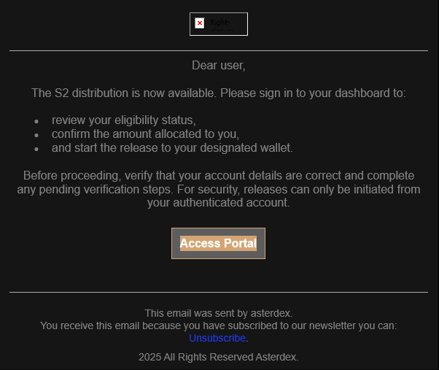

Scam
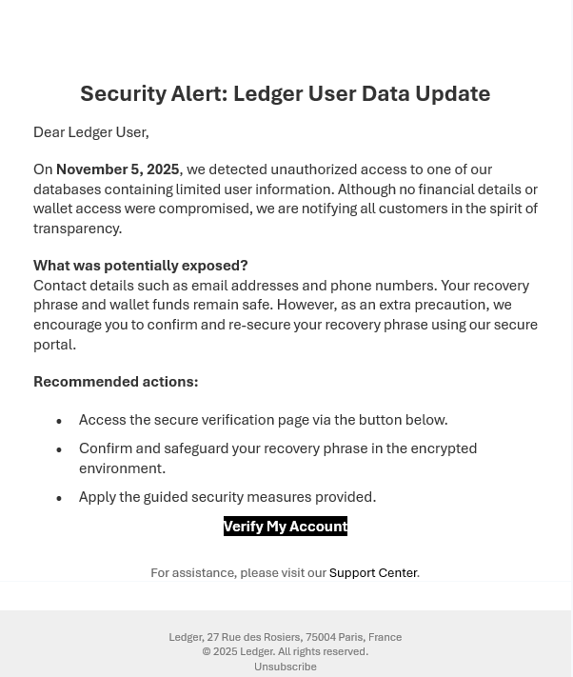

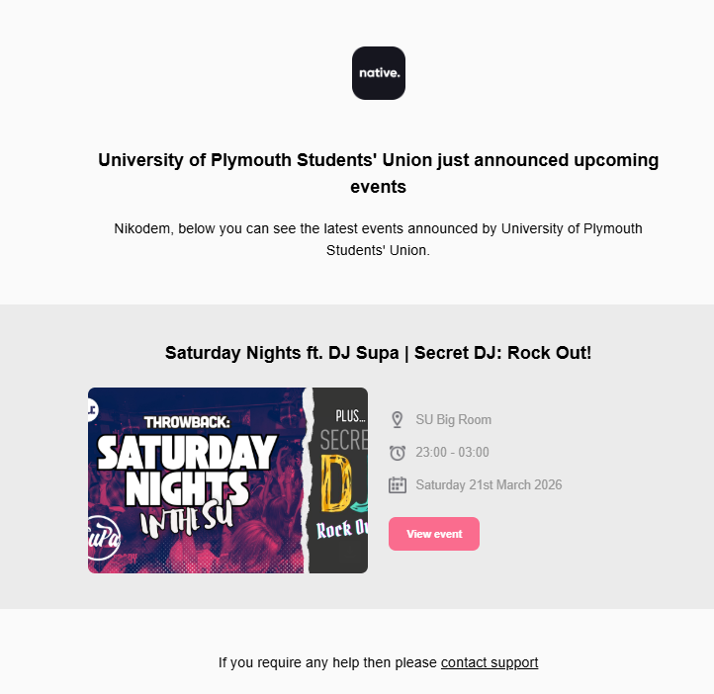
Legitimate

Legitimate
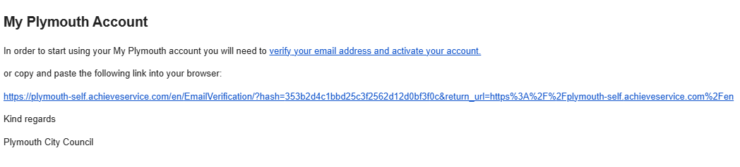

Legitimate
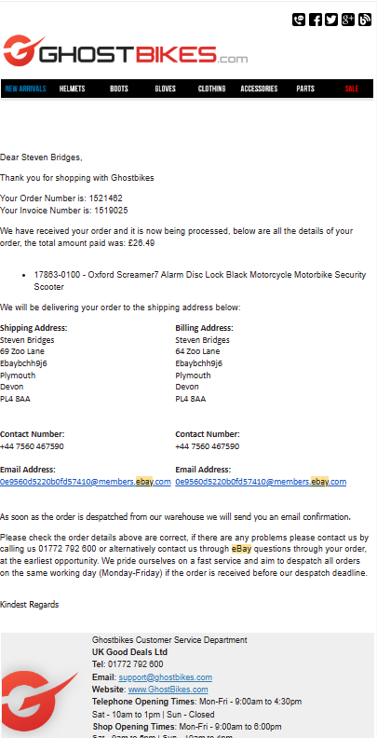

Scam
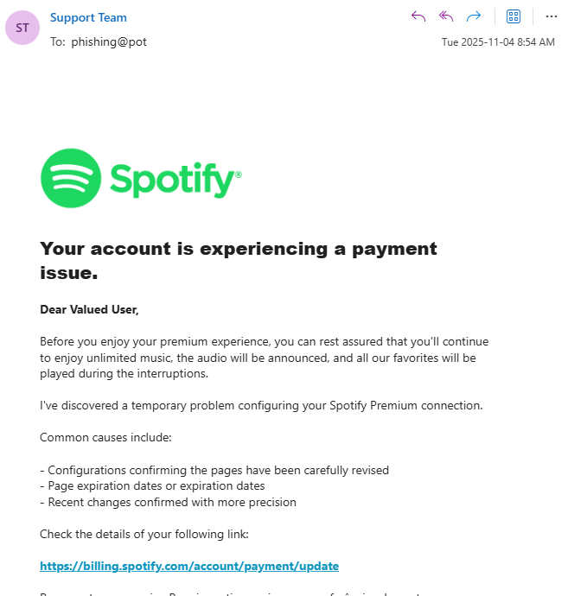

Outcome
Based on the testing of users I have deducted that there is around a 50% chance that the user will not be able to correctly identify if an email is a scam or real email.
This indicates that my target market may be wider than initially anticipated and that user awareness is much lower than I initially anticipated.

Re-testing with application
After the user got familiar with the extension I retested them by providing them with an email they saw previously and re-examined to establish if the application improved awareness.

Scam


Outcome
In conclusion the users average rating increased from 6 to 6.5 this indicates that the software improved awareness of scam email

Legitimate


Outcome
In conclusion the rating decreased from 8.5 to 6.2. This indicates that users identified that his email was less likely to be a scam email.

User testing
In this section I received feedback on the UI and user experience of the tool. In this section
- very unconfident
- 10 is very confident

Open the tool
AVG: 8.5
Issue – Not used to chrome extensions
Fix – User experience

Navigate to security settings
AVG 6.5
Issue – Icons are confusing. Shield in not visible and interpreted as security
Fix- change UI to explicitly state the settings and security tab is more defined

Modify Security Settings
AVG: 8.2
Issues -
- User unsure if the settings are saved or not.
- User unsure what the text size indicates ( Final size)
- Language is a little ambiguous
Fix –
- Improve user feedback
- Add text size indicator
- Review language used

Review what services are available
AVG 9.2
Isssues -
- User was unsure what services are.
Fix –
- Add description

Scan Email / run tool
AVG 9.2
Fix -
- Change the wording on the button

Analyse the analysis information
AVG: 10
Issue -
- May be hard to read red text on black.
Fix -
- Allow user to change the setting for this Aswell.

Other Feedback
- To be able to preview warning message before running software (to gauge how changes impacted)
- Improve on the explanation of the risk scale.
  - Modify it to be larger possibly out of 100 to better disengage between phishing and not a scale of 1-5 is unlikely to be sufficient.
  - Users indicated if it’s not 0-1 then they are not clicking it
  - Ensure users understand scale of risk what each section determines.

Improvements

Shield Icon
Modified it from a shield to now being a padlock with a different colour. Aim is to be easier to differentiate than a shield.
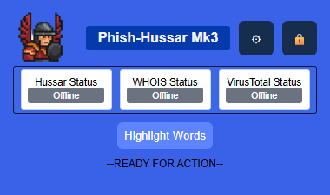

Preview Warning Message
Added an on-hover text box that when interacting with provides user with a preview of what the text will look like. This only appears on hover to simplify user interface.
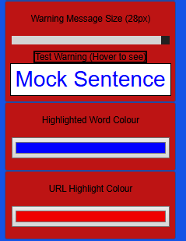

Application Feedback
User gets updates on most changes of state in the process to reinforce the fact the application is working
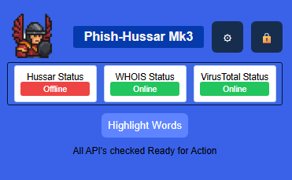

Risk Scale Testing.
Based on the feedback received there are to possible solutions to the issues regarding the risk score.
- Implementation of an explanation of acceptable risk.
- Increase to 100 and creating a non-linear / weighted risk score

User Explanation
This solution would fit in with the current risk analysis and would only provider a uniform explanation. To what each number represents.
0.0  (Fatal Error) | 0.1-1  (100% Safe) | 1.1-2.0  (80% Safe Minimal Flags) | 2.1-3.0  (Medium Risk  Multiple flags) | 3.1-5.0  (High Risk)

Non-Leaner risk score
Aims
- Priorities critical threats instead of all possible threats
  - Current solution -> small risk equally reflected in a score increase
- Improve trust in system
  - Overall lower threat scores
In conclusion, apply a computed weighted sum with exponential scaling to improve the confidence in indicators.

Solution
BOTH

Sprints
Sprint Date – The time the sprint was performed
Format: Month / Week of the month 1-4
4/W2 (April week 2)
Objectives – The aims of the sprint
Achieved & TBD – The achieved objectives and from that sprint any new discoveries and items “to be done” (TBD)
Achieved
To Be Done
SPRINT DATE | OBJECTIVES | ACHIEVED & TBD
10/W2 – 11/W2 | Planning and research of project learning different possible solutions | Market research  Project Idea  Software solutions
11/W1 11/W3 | Experiment with the possible solutions begin prototyping | Created an email scraper using google online software.  Store emails in the users google spreadsheets.  UI is implemented partially has working buttons and scrapes emails. Added settings to choose how long back to scrape and how many emails to scrape at one time.  Identified issues where the software scraping is limited by the ecosystem. Difficult to set up.
11/W4 12/W2 | Change from google script to full JS on the extension side | Ported scraper to use JS to read the HTML and identify body of email. Scrape the email and inject CSS to be able to highlight the words. Added code to view Risk on Hover of the highlighted word/link.  Implemented a variety of pre-determined reasons for warnings to be displayed for the user so they learn.
12/W2 1/W1 | Documentation period and testing period of current prototype. Additionally, study on different coursework no valuable coding done. | Testing and feedback on first UI changes to improve the work.
1/w2 1/w4 | Implement code to scan URLS provide risk score and use API’s to be able to gather additional URLS | Code now isolates URLS to scan them and use WHO IS API and VirusTotal database to gain additional data regarding URL. Implemented my own risk analysis score and used the other databases to verify my own research. Testing highlighted the use of URL redirects. Now need to implement URL extenders.
2/w1/ 2/w2 | Implement URL extender API. | Created my own API that can be called to extend any URL and identify its destination using header.  Added ability to query the database using API to get bad words that are in the email. Partially works needs more work.  Ran usability tests and identified issues that need to be fixed.
2/W3 3/W1 | Documentation and other CW | PowerPoint and Main documentation work updated.
3/W2/ 3/W3 | Improve API attempt HTTPS  Improve user experience | Re-designed UI  API’s now get a health ping to inform user of their status on launch  Improve user control on what is used and performed in app.  Attempted to apply HTTPS to my Hussar API issues with certification and access to API.

Final Solution

Architecture

Code Base
Two tables that describe what each application does and their interactions.

Phish-Hussar
File name | Use Case | Used By
manifest.json | Chrome extension manifest declares permissions, background worker, popup, and Gmail content scripts. | Chrome runtime (entrypoint for entire extension).
BackGround_WORKER.js | Service worker that handles cross-origin/API tasks (VirusTotal calls, Hussar API /extend and /scan, health checks) via chrome.runtime.onMessage. | Loaded by manifest.json; receives messages from check_url.js, highlight_words.js, and HTML_Controler.js.
Extention.html | Popup UI layout (settings/security toggles, API key inputs, API status, highlight button). | Opened as extension action popup from manifest.json.
style.css | Styling for popup UI components in Extention.html (layout, buttons, switches, status badges). | Linked by Extention.html.
HTML_Controler.js | Popup controller: loads/saves settings to chrome.storage, checks API status, injects content scripts into Gmail tab, sends "highlight" command. | Loaded by Extention.html
check_url.js | URL risk analysis engine (protocol/TLD/path checks, WHOIS age/expiry checks, VirusTotal scoring, redirect chain analysis and calculates final risk score). | Included as content script in manifest.json; also loaded in popup by Extention.html; called by highlight_words.js (Check_URL).
highlight_words.js | Main Gmail content scanner injects CSS, highlights suspicious words/URLs, attaches hover warnings, triggers URL risk checks word regex. | Included as content script in manifest.json. Injected by HTML_Controler.js
Bad_Words_List.js | Defines and exposes window.BAD_WORDS (word list used for highlighting baseline terms).  Used for testing | Included as content script in manifest.json; referenced by highlight_words.js; injected by HTML_Controler.js.
Warnings_List.js | Defines warning message map window.Warnings_Mini_DB keyed by warning IDs for tooltip text. | Included as content script in manifest.json; referenced by highlight_words.js; injected by HTML_Controler.js.

Phish-Hussar API
File name | Use Case | Used By
app.py | Main Flask API service. Exposes /extend, /scan, /test, configures CORS + rate limiting, and handles URL expansion + phishing-word scan requests. | Chrome extension client, manual API callers, gunicorn (via Dockerfile).
db_Controller.py | Data-layer helper for phishing word detection. Loads bad words from SQLite and checks incoming text tokens against cached bad-word set. | Imported and called by app.py (load_bad_words, check_for_bad_words).
requirements.txt | Python dependency manifest (flask, requests, flask-cors, flask-limiter, redis, etc.). | pip install -r requirements.txt, Dockerfile image build step.
Dockerfile | Container build/run definition for production-style execution using gunicorn on port 5443 with TLS cert/key files. | Docker build/runtime pipeline.
cert.pem | TLS certificate file used for HTTPS in containerized gunicorn command. | Dockerfile runtime command (--certfile=cert.pem).
key.pem | Private key paired with cert.pem for TLS termination in container runtime. | Dockerfile runtime command (--keyfile=key.pem).

Technology

Client Side
A predominantly Client-Side architecture has been used to maximise scalability and privacy.
Executing most processes and calculations within the user’s browser reduces resilience on third party servers and as a result aligns with the project objectives of maximising user control.
From a scalability standpoint, utilising client resources reduces the cost of operation and need for complex infrastructure such as load balancing and servers, making it more cost effective and efficient to deploy. The users use minimal resources from 3rd party only to perform data queries.

APIs

Virus Total
Virus total was selected as a primary threat intelligence source to its comprehensive database that is continuously updated by open-source projects as well as malware and web security firms.
A limitation of Virus Total this is the additional scope of implementation and the rate limits, however despite this; the breadth and quality of data justify the inclusion as a supporting component of the solution increasing the accuracy of results; due to the fact more data sources can eliminate false results. Additionally, its well documented and widely adopted, making it suited for integration and is reliable.

WHO IS
WHO IS was incorporated to supply domain intelligence to identify phishing characteristics of webpages.
It is crucial to identify domains age and registration details. New web pages are often identified as fishing and may not yet be blacklisted. As a result, is possible to identify suspicious websites.
This complements Virus Total by applying additional layer of analysis performing and identifying suspicious signatures.
WHOIS API allows for automated real time revival if up to date data providing users with actionable insight

Pipeline
The final solution follows a multistage processing pipeline to enable phishing detection.

Content Extraction
After starting extension, the file scans the DOM a extracts the following:
- Email Body
- Embedded URLs
- Plain text links
And prepares the raw data for analysis.

Analysis of Content

URL
Using WHOIS database, Virus total and URL analysis we evaluate the following:
- All the things from Check URL
We then evaluate the risk score by the average of all these categories.

Text
The Email Body is sent to the Hussar API. This API then tokenises the email body and performs a searcher query for if the words are in the database and then their risk score is returned the SQL database for the words in the database.
If the risk score is high enough, they are presented and highlighted.

Regex analysis an Sanitisation
Filtering and sanitation and the email body removing any special characters and URLs to prepare for analysis. The aim is to prevent SQL injection and other code injection-based attacks.

User Interface

Considerations
Issue - Wide target market likely to have accessibility issues.
Solution – Custom Accessibility settings to allow modifications

Issue – User Understanding What services are available.
Solution - On startup check services is alive.

Final Performance

Security & Privacy
Security and Privacy are the core values of the solution. The software addresses security risks in the browser and API communication ensuring minimal data is used and stored.

Chrome Extension Security
- Minimum permissions are asked for when using the software.
- API calls are sanitised
- All user inputs are sanitised.

Secure Communication

HTTPS
The Phish-Hussar API communication is conducted over HTTPS. Using TLS allows for encryption of the content in transit using a TLS certificate and a KEY to decrypt, protecting data in transit
The aim is to prevent interception of data and Man-in-the-Middle attacks. HTTPS uses cryptography compared to HTTP which is plain text communication. This ensures the confidentiality, integrity and authenticity and makes the interception useless based on the current state of decryption technology.

API Security

DoS Prevention
The Hussar API has rate limiting based on user IP. This is intended to prevent Denial of Service. However, it’s unlikely to stop a DDoS due to the rate limit being per user. Additionally, development of DDoS prevention techniques is not a valuable resource consumption for this MVP.

Sanitisation
The API has sanitisation additionally to sanitisation before transmitting to ensure that the data received is of correct format even if it has its packets altered. Ensures the SQLite is correctly accessed and minimises access and exploitability.

User Choice
As the user’s privacy is most important it’s vital to ensure that they have full control over the application. AS a result, it’s possible to disable and enable each of the applications tools. However, this comes with the downside of lower accuracy.

Error Handling

Deployment

Beta Deployment
Deployment of the MVP to Beta Testin will follow the following plan:
- Download File from GitHub
- Add to browser extensions
  - Enable Developer Mode
  - Load Unpacked
  - Select Software
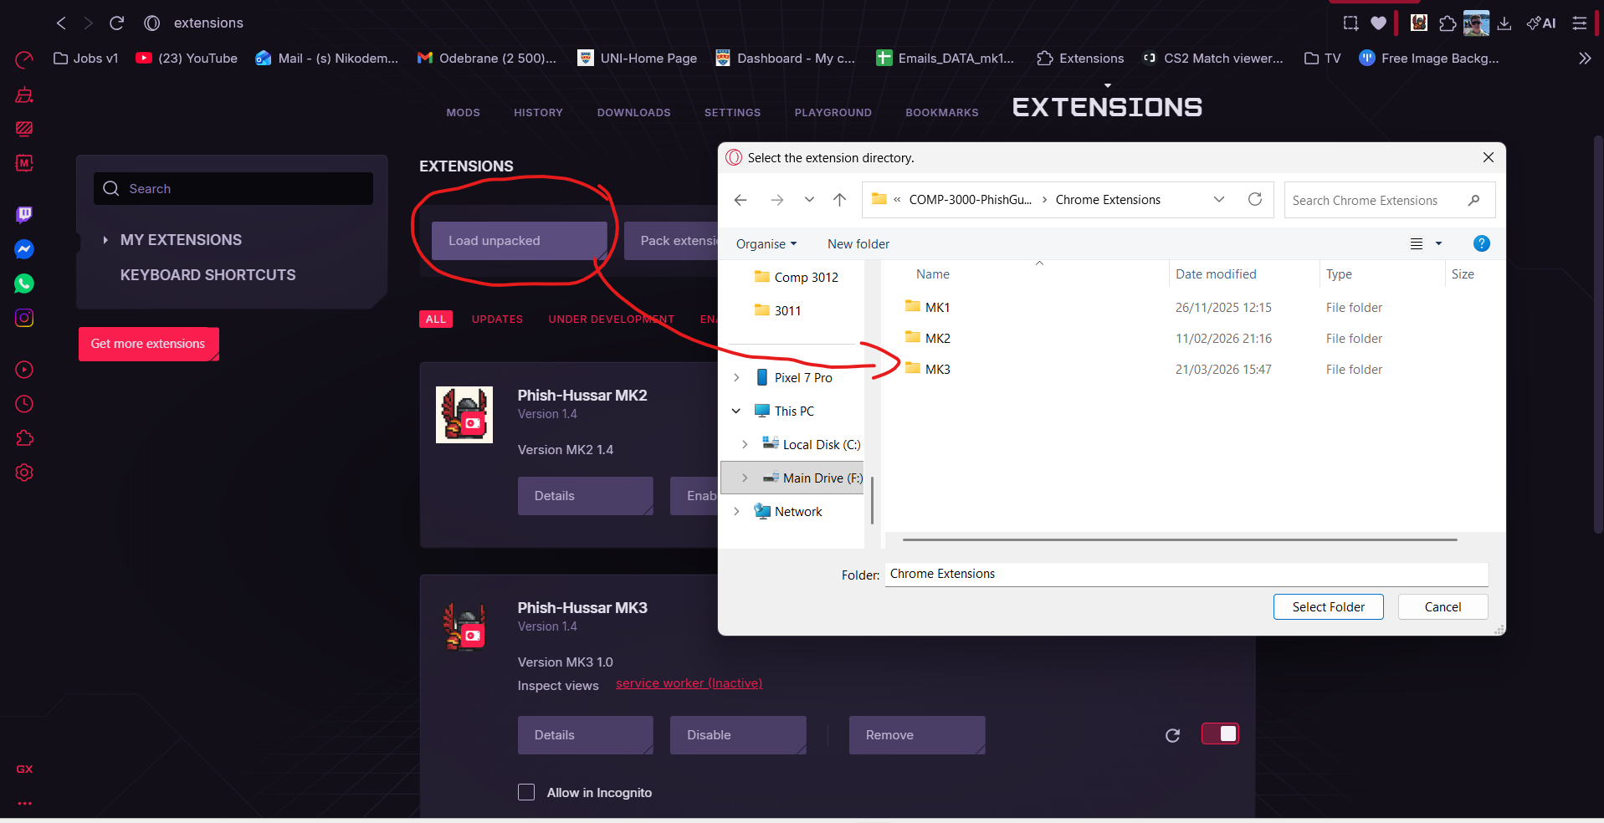
- Upload All API keys
    - Who IS
    - Virus-Total
- Modify Settings to users liking
During this period continuously improve and fix and issues identified prior to deployment. Additionally, this would be a free open-source project and as a result of these certain areas will not be fully user friendly for setting up. And will require documentation.

Production Deployment
For the final production it’s intended to publish on the google extensions for this post MVP and the following checklist must be completed prior to this.

User Data Policy and EULA
- Create a legally binding EULA and Data Policy
  - Detail the data processing to the user
  - Declare what data is share with which third party
- Ensure all features are compatible with Google’s User Data Policy.

API
- Phish-Hussar API hosted on a reliable cloud service. (AWS)
- HTTPS TLS not self-assigned
- Load Testing preformed and implemented load balancing if needed.

Cost
The primary cost deployment includes.
- Hosting and maintain phish-hussar API cloud infrastructure.
- Publishing and maintain the extension on the chrome web store.

This can be covered by donations however this is unlikely to cover costs. The secondary options are to require payment to use the API I am providing.

API payments
As a result of this, a paid API model may ensure long term sustainability following the style of all other API companies. This would involve the following additions:
- API key-based authentication to track individual user usage
- Introduction of tired pricing.
  - Free tier to try applications
  - Paid tiers based on usage
This will ensure operational costs are covered while allowing general access. Additionally, it improves security from DoS attacks and excessive and malicious requests as all calls are traceable to accounts

Documentation / Tutorial
Prior to use of the application for the target market this is intended for they would benefit from a document and possibly video tutorials.
The aim is to teach users with the least possible experience how to use the software and set it up in their environment.

Evaluation

Requirements
For the MVP to be valid the solution must complete all the requirements bellow

Functional Requirements
FR1 | ✓
FR2 | ✓
FR3 | ✓
FR4 | ✓
FR5 | ✓
FR6 | ✓
Fr7 | ✓
Fr8 | ✓
FR9 | ✓
FR10 | ✓
FR11 | ✓

Non-Functional requirements
NFR1 | ✓
NFR2 | ✓
NFR3 | ✓
NFR 4 | ✓
NFR 5 | ✓
NFR 6 | ✓
NFR 7 | ✓
NFR 8 | ✓
NFR 9 | ✓

Conclusion
All MVP requirement metrics have been met because of this the software is ready for a small beta testing.

What Went Well

What Need Improvements

CPD
In this section I will discuss things performed to ensure continuous personal development.

PlymHack 2026
During plymhack I developed the following skills
- Team Building
  - I was tasked with developing a team to work alongside me to develop the event
- Team Management
  - Learnt about organising, task delegation and ensuring tasks are completed withing the time frame
- Agile working environment
  - Ensured that the event followed Agile
    - Had Fortnightly meetings
    - Set objectives
    - Discussed challenges
    - Identified solutions
- Project management
  - Identified issued that needed to be solved
  - Organised logistics for the event
  - Managed Event Budget
  - Worked on 3 different time zones
- Risk assessment
  - Assessed Risk and created contingency plans
- Presentation
  - Created a presentation
  - Presented across the world
In conclusion plymhack taught me about what it’s like to organise a large team and orchestrate communication and events between departments to ensure smooth sailing. I developed a better understanding of different requirements that are necessary to organise an event and creating contingency planning for any risks. Additionally, due to the large number of meetings, I improved my skill in meetings. By the end I was able to have short and efficient meetings that discussed everything as I created in depth Agendas and the meetings were of better quality.

Devon & Cornwall Forensics
I attended a Digital Forensics Talk to learn what it means to be a digital forensics investigator and the daily procedures that are performed and different methodologies they do to achieve their objectives.
- Scripting
  - Investigators often use python and bash/PowerShell scripts to automate tasks that do not have tools/solutions made
- Learnt about the chain of custody
- Learnt about ACPO guidelines
  - Learn about the importance of ACPO and the steps taken to ensure the data collected is valid in court
- Learn about data acquisition
  - Type of data that is collected
  - What type of data can be collected from different sources
  - How data from different sources can illustrate a chain of events
Attending this talk it brought into perspective how the data I’m accessing can be used to digitally identify a user. As I may be accessing sensitive materials how does these data streams affect my application and how do I ensure that the data does not remain on any service.wrtie more about this
Possible User testing

References – Words 601
[1] Government of the UK (2025) Cyber security breaches survey 2025, GOV.UK. Available at: https://www.gov.uk/government/statistics/cyber-security-breaches-survey-2025/cyber-security-breaches-survey-2025.
[2] Smolen, P., Zhang, Y. and Byrne, J.H. (2016). The right time to learn: mechanisms and optimization of spaced learning. Nature Reviews Neuroscience, [online] 17(2), pp.77–88. doi:https://doi.org/10.1038/nrn.2015.18.
[3] Lyons, S. (2021). NCSC’s new cyber security training for staff now available. [online] www.ncsc.gov.uk. Available at: https://www.ncsc.gov.uk/blog-post/ncsc-cyber-security-training-for-staff-now-available.
[4] 2025 Data Breach Investigations Report 2025 Data Breach Investigations Report (2026). Available at: https://www.verizon.com/business/resources/T977/reports/2025-dbir-data-breach-investigations-report.pdf.
[5] Impact Report (no date). Available at: https://cf-assets.www.cloudflare.com/slt3lc6tev37/7koyyovVxIqK8zdG1pqo6O/dfcbbde950394c61855befd9bf083a28/Impact-Report-2025-Final.pdf (Accessed: 21 March 2026).
‌[6] Cloudflare (2023) 2023 Phishing Threats Report. Available at: https://cf-assets.www.cloudflare.com/slt3lc6tev37/17i1am3UMltoOE7UOU1neX/5776ab933524b3cf99ee85eaaedc76f6/BDES-4838_2023_Phishing-Threats-Report-2023.pdf.
[7] LexisNexis (2021) Under 25s Most Vulnerable to cyberattacks, According to LexisNexis® Risk Solutions Global Cybercrime Report | LexisNexis Risk Solutions, LexisNexis Risk Solutions | Transform Your Risk Decision Making. Available at: https://risk.lexisnexis.co.uk/about-us/press-room/press-release/20200223-biannual-cybercrime-report.
[8] Age UK (2024) More than 1 in 3 over 65s (4.7 million) Lack the Basic Skills to Use the Internet Successfully, Age UK. Available at: https://www.ageuk.org.uk/latest-press/articles/2024/more-than-1-in-3-over-65s-4.7-million-lack-the-basic-skills-to-use-the-internet-successfully/.
[9] Gwenhure, A.K. (2025) ‘University students’ security behavior against email phishing attacks: insights from the health belief model’, Journal of Cybersecurity, 11(1). Available at: https://doi.org/10.1093/cybsec/tyaf034.
[10] 2025 phishing statistics: The alarming rise in attacks - Zensec (2025) Zensec. Available at: https://zensec.co.uk/blog/2025-phishing-statistics-the-alarming-rise-in-attacks/.
[11] Heiding, F. et al. (no date) Evaluating Large Language Models’ Capability to Launch Fully Automated Spear Phishing Campaigns: Validated on Human Subjects. Available at: https://arxiv.org/pdf/2412.00586.
‌[12] Parliamentary Office of Science and Technology (2001) (n.d.) POSTnote 156, UK Parliament. Available at: https://www.parliament.uk/globalassets/documents/post/pn156.pdf
[13] Anonymous Author(s) (2024) ‘7 Days Later: Analysing Phishing-Site Lifespan After Detected’, OpenReview. Available at: https://openreview.net/pdf?id=R8mltlB42N & pure.skku.edu/en/publications/7-days-later-analyzing-phishing-site-lifespan-after-detected/
[14] ENISA (2023) ENISA THREAT LANDSCAPE 2023 ABOUT ENISA EDITORS. Available at: https://www.enisa.europa.eu/sites/default/files/publications/ENISA%20Threat%20Landscape%202023.pdf.
[15] Toth, R. et al. (2025) Sustaining Cyber Awareness: The Long-Term Impact of Continuous Phishing Training and Emotional Triggers, arXiv.org. Available at: https://arxiv.org/abs/2510.27298.
‌

‌

‌

Extensions
PIXMM:
https://chromewebstore.google.com/detail/pixm-phishing-protection/flomofhkchlalfciiibgbfcpolhmglai
Criminal IP:
https://chromewebstore.google.com/detail/criminal-ip-ai-based-phis/dhkbjdnlhahnffncheehbnoaecncdpdk
Anti-Phishing:
https://chromewebstore.google.com/detail/anti-phishing/npipcajipdkafdkellochifbfmppdalo

‌

Apendix

Risk Assessment Methodology
Likelihood | In the event of an attack likelihood this “xxx” would be target or used
Impact | In the event of an attack the impact this poses to the success or damage of the attack

RISK = Likelihood * Impact

Likelihood | Explanation
Rare -1 | High level vulnerability. Requires advanced techniques. No previous breaches and multiple levels of prevention implemented to mitigate.
Unlikely - 2 | High Level. Requires access to restricted hardware or software to breach. Example an employee device
Possible - 3 | Known attack technique with known prevention methods to mitigate risk implemented not fully prevented.
Likely - 4 | Low level technique required to breach with little mitigation implemented. CTI identified risk.
Almost Certain - 5 | Low level technique used Widley across sector well documented as a CTI risk. No prevention methods put in place to restrict attack.

Impact | Explanation | Possible University Impacts
Negligible -1 | No impact on operation. No effect on data. No legal effect. | Nothing
Low - 2 | Minor disruption in operation, decrease in operational efficiency. Limited noncritical data exposure. | Minimal Time Loss
Medium – 3 | Disruption to workflows noncritical systems affected. Exposure of non-sensitive personal data. Non sensitive/critical data exposed. | Time loss  Resources to fix error
High - 4 | Disruptions to critical systems  Compromise of non-critical data. Personally identifiable data or minor critical research data exposed | GDPR investigation  >1 week time loss  Loss of systems  Delays on development
Critical – 5 | Critical Systems inoperable for prolonged period.  Compromise of critical data. Exposure of sensitive documents regarding staff or infrastructure. | >2week time Loss  Fines Incurred  GDPR breach

‌

‌

‌

MORE STUFF
https://www.kaggle.com/datasets/subhajournal/phishingemails?resource=download
‌epsilon adds 0.000001 to the number so in case its 0 its not an error.
$$risk=\frac{Frequency in Fishing+1e-6}{Frequency in Normal+1e-6}$$